CS 255 System Design Document Template

UML Diagrams

UML Use Case Diagram

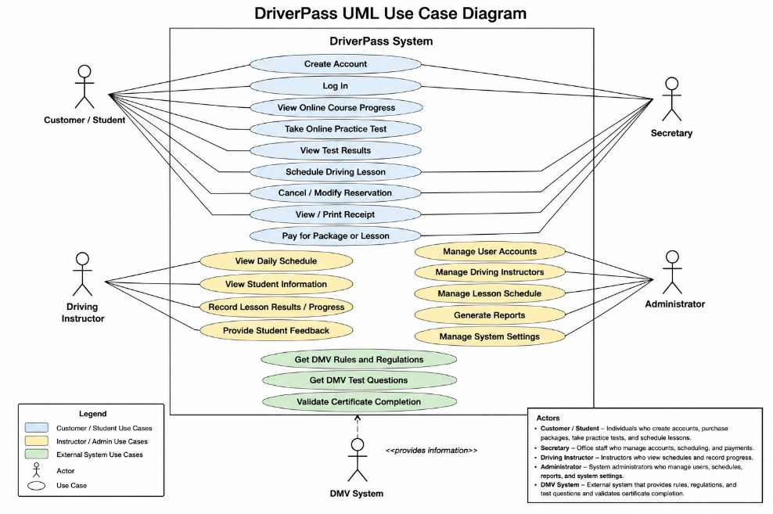

UML Activity Diagrams

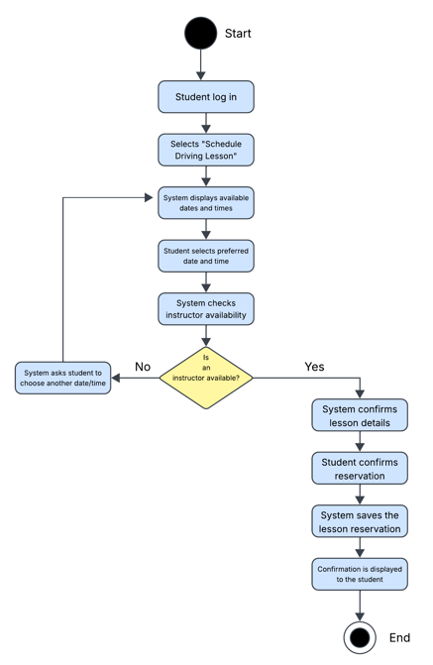
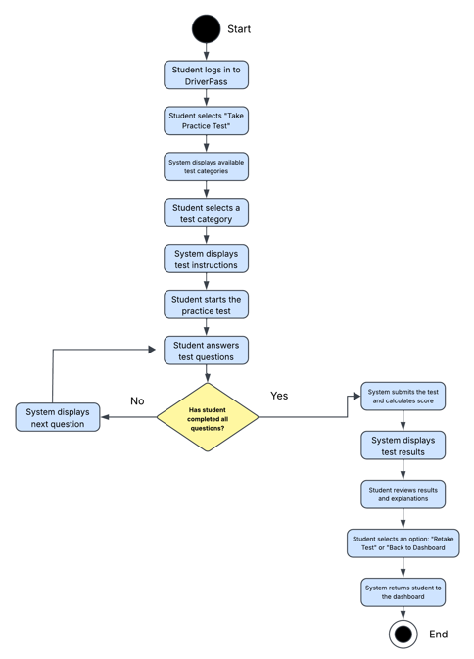

UML Sequence Diagram

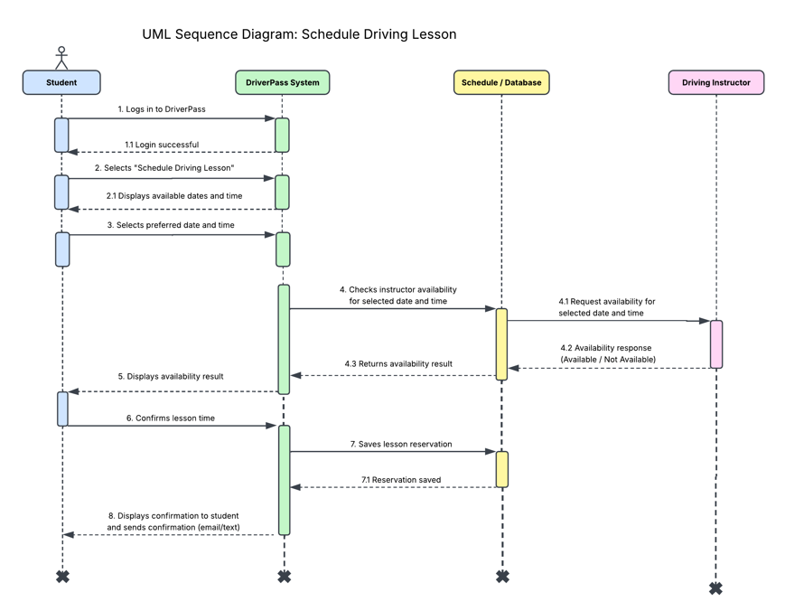

UML Class Diagram

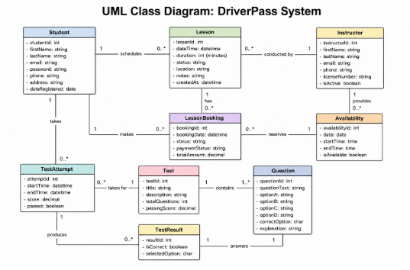

Technical Requirements

The DriverPass system will require reliable hardware, software, and network resources to support students and employees. Users will need an internet-connected computer, tablet, or mobile device with a modern web browser to access the system. DriverPass employees will also need computers with reliable internet access to manage customer accounts, lesson schedules, student progress, and other system information.
The system will require a web-based application connected to a secure database that stores user accounts, reservations, lesson information, practice test results, payment information, and instructor schedules. The database and application should be hosted on reliable servers or cloud infrastructure so that customers and employees can access the system when needed. Regular backups should also be maintained to protect important business and customer information.
Security measures should include password-protected accounts, different access permissions based on the user's role, and encryption to protect information transmitted through the system. The system should also use secure connections when customers submit personal or payment information. Software and security updates should be performed regularly to help protect the system from vulnerabilities.
The DriverPass system must also support communication with external resources, including DMV information used for current rules, regulations, and practice test material. The system should be designed so that this information can be updated as requirements change. Testing and monitoring tools should be used throughout development and after deployment to ensure that the system remains reliable, secure, and available to users.
That should be plenty for this section. It addresses exactly what the instructions ask for: hardware, software, tools, infrastructure, security, database/storage, networking, and external DMV information.

